Multiple Choice: For each question, identify the choice that best completes the statement or answers the question.
- Why were Spain and Portugal the countries that “kick-started” the age of Exploration?
  - They were the richest countries before exploration began.
  - They had the closest relationships with Chinese emperors.
  - Their geographic location on the Iberian Peninsula was advantageous.
  - Only the Spanish and Portuguese knew how to use the astrolabe.

- Henry the Navigator is named as such because
  - He was the first European to circumnavigate the globe.
  - He was a patron and supporter of voyages of exploration.
  - Navigator is Dutch for “ship captain”
  - He was the first European to land in the Americas.

- The astrolabe performed which of the following tasks?
  - It told sailors what the weather was like ahead of them.
  - It always pointed to the North Pole, no matter what.
  - It carried European explorers across the ocean much faster than previous ships.
  - It measured latitude and could tell sailors what time it was.

- How did the Renaissance contribute to the Age of Exploration?
a. | by emphasizing the importance of converting people to Christianity
b. | by awakening a spirit of discovery and innovation in Europe
c. | by fostering a belief in the importance of working as a group
d. | by persuading Europeans that the pursuit of wealth was all-important

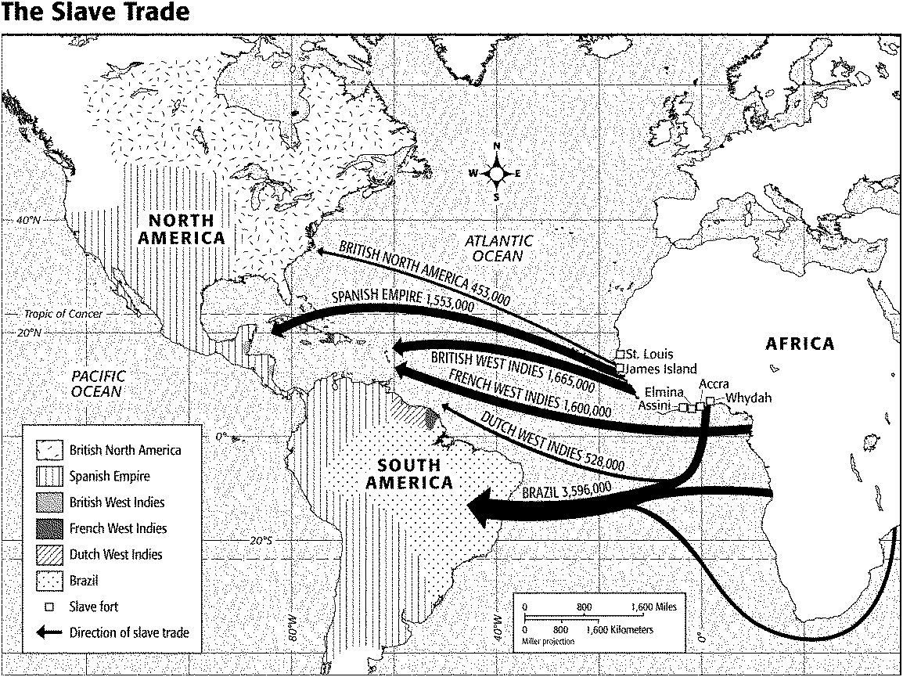
5. According to the map titled “The Slave Trade,” where were most slave forts located?
a. | the Cape of Good Hope | c. | the Middle Passage
b. | the west coast of Africa | d. | Brazil

- According to the map titled “The Slave Trade,” the British imported approximately how many slaves to their colonies?
a. | 1.7 million | c. | 3.6 million
b. | 2.1 million | d. | 9 million
- According to the map titled “The Slave Trade,” the greatest number of African slaves were taken to
a. | British North America. | c. | the British West Indies.
b. | Brazil. | d. | the French West Indies.

“Our plantations. . . consume more of our home manufactures. . . they produce commodities indispensably necessary to this part of the world, and not to be produced elsewhere, and, with industry and conduct, may be made an inexhaustible mine of treasure to their mother kingdom.”
—Charles D’Avenant, “An Essay on the East-India Trade”

- The passage by Charles D’Avenant justifies which of the following?
a. | colonization | c. | bullionism
b. | industrialization | d. | subsidies

“The stench of the hold. . . was so intolerably loathsome, that it was dangerous to remain there for any time. . . The closeness of the place, and the heat of the climate. . . almost suffocated us. . . The shrieks of the women, and the groans of the dying, rendered the whole scene of horror almost inconceivable.”
—Olaudah Equiano, The Interesting Narrative of the Life of Olaudah Equiano, 1789

- In the passage by Olaudah Equiano, he describes
a. | plantation life. | c. | a slave ship.
b. | indentured servitude. | d. | an encomienda.
- European kingdoms and individuals were motivated to explore for all of the following reasons EXCEPT
- They were searching for a cure for the black plague
- They wanted to spread their religious beliefs
- They wanted wealth and fame
- The spirit of the scientific thought and reason during the Renaissance made many explorers curious about their world

- All of the following countries were active in voyages of exploration EXCEPT
  - Portugal
  - Spain
  - Netherlands/Holland
  - Germany

- The ultimate goal of the early Portuguese explorers was to
  - Find a water route around Africa to India
  - Discover new lands
  - Explore the coast of Africa
  - Spread Christianity

- Which of the following was NOT a cause for the Europeans to begin importing African slaves?
a. Encomienda
b. Loss of native slave labor to disease
c. Mercantilism
d. Lack of interest by Europeans to move to the colonies

- The portion of the Triangle Trade that moved slaves from Africa to the Americas was known as the…

a. Middle Passage
b. Northwest Passage
c. Bering Strait
d. Cumberland Passage

- What was the ultimate destination for 80% of all slaves taken out of Africa?

a. Mexico
b. Cuba
c. Brazil
d. 13 Colonies

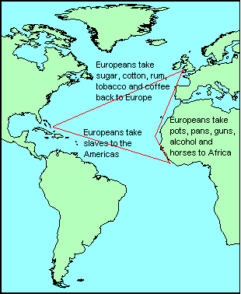

- According to the map above what was a example of an item traded in Africa for slaves?

a. Cotton
b. Guns
c. Slaves
d. Tobacco

- According to the map above what was an example of a crop harvested by slaves in America and taken to Europe?

a. Iron
b. Wheat
c. Gold
d. Sugar

18. What weapon helped to kill millions of Native Americans?

a. Animals
b. Guns
c. Disease
d. Nuclear weapons

19. Which of the following items would be most appealing to a mercantilist?

a. a book/education
b. a church/religion
c. a captains log/boat
d. gold/wealth

20. What impact did the Columbian exchange have on the New World?
a. Destroyed the Native population and created colonies in the New World
b. Destroyed the European population and created colonies in the Old World
c. No impact was evident from the Columbian Exchange
d. Both the Old World and New world prospered

 | Old World to New World: | New World to Old World:
Diseases | Smallpox  Measles  Chicken Pox  Malaria  Yellow Fever  Influenza  The Common Cold | Syphilis
Animals | Horses  Cattle  Pigs  Sheep  Goats  Chickens | Turkeys  Llamas  Alpacas  Guinea Pigs
Plants | Rice  Wheat  Barley  Oats  Coffee  Sugarcane  Bananas  Melons | Corn (Maize)  Potatoes (White & Sweet Varieties)  Beans (Snap, Kidney, & Lima Varieties)  Tobacco  Peanuts  Squash  Peppers  Tomatoes

21. According to the chart above, what were the overall effects of this exchange on the Europeans?
- The Europeans discovered new crops and they brought them to the old world
- Nothing changed from this interaction
- The Europeans discovered horses and they brought them back to Europe
- The Europeans caught different diseases such as smallpox in the new world

22. According to the chart above, what were the overall effects of this exchange on the Native Americans?
- The Native Americans caught a new disease called Syphilis from the old world
- The Native Americans discovered new crops in old world, such as Avocados
- Nothing changed for the Native Americans
- The Native Americans were given diseases by the Old world people, which destroyed their population

23. What were the three main groups exchanged during the Columbian exchange?

- Pigs, Beans, and Diseases
- Diseases, Animals, and Plants
- Avocados, Kentucky Bluegrass, and Animals
- Plants, Smallpox, and Horses

24. Which of the following best defines mercantilism?

a. an economic system where businesses provide goods and services to people in exchange for money
b. an economic system where land is exchanged for loyalty and/or services
c. the dominant economic system in Europe during the Age of Exploration through the 17th century
d. the triangular flow of trade between Europe, Africa, and the Americas

25. In the mercantilist system, the colonies existed solely for what purpose?

a. a place for excess populations in Europe to live
b. to benefit the mother countries and provide them with profit
c. to rebel against mother countries and declare independence
d. to provide finished, manufactured goods to mother countries in Europe

26. Mercantilists believed what major problem existed in the world?

a. there was only a limited amount of wealth that existed in the world
b. there were not enough Christians in Europe
c. there was not a reliable method to continuously cross the Atlantic Ocean
d. there was only a limited amount of glory that one could gain from conquering territories in the New World

27. Due to the answer to number 26, what happened as a result of mercantilism?

a. European nations existed in a state of constant peace and harmony
b. European created peace agreements that allowed them to share the wealth from their colonies
c. Europeans were in a state of constant warfare with Middle Eastern, African, and Asian countries
d. European countries were in a state of fierce competition amongst one another

Constructed Response:
For following bundle of Constructed Response questions you must answer questions #1 and #2 (they are in bold). Then choose either question #3 or #4 to answer. Be sure to include specific examples/details when appropriate.

- Explain the motivations for why European’s set out to explore in the 1400’s and 1500’s. How did the Renaissance contribute to the Age of Exploration? Give specific examples for every reason.

- Why did mercantilism lead to intense competition between nations for wealth during the 1500s and 1600s? How did mercantilism affect European colonization of other parts of the world?

- How did French colonization of the America’s differ from that of the Spanish and Portuguese colonization of the America’s? Give specific examples on how each colony is different.

- Explain Triangular Trade? Describe in detail each leg of this trade route.

You are required to answer the following primary source constructed response questions.

The Spanish “Requisition”- an announcement that the Spanish explorers (conquistadors) read to the Indians when they arrived in a new land. Note: it was read in Spanish, even though the Indians did not speak Spanish.

I implore (beg) you to recognize the Church as a lady and in the name of the Pope take the King as lord of this land and obey his mandates. If you do not do it, I tell you that with the help of God I will enter powerfully against you all. I will make war everywhere and every way I can. I will subject you to the yoke and obedience to the Church and majesty. I will take your women and children and make the slaves... The deaths and injuries that you will receive from here on will be your own fault and not that of his majesty nor of the gentlemen that accompany me.

5. Based off of the passage above explain the attitude of the Spanish explorers towards the natives already living on the land. Do you believe that the Spanish are justified in their thinking when it comes to claiming new land? Explain why you believe the Spanish are or are not justified in their thinking.

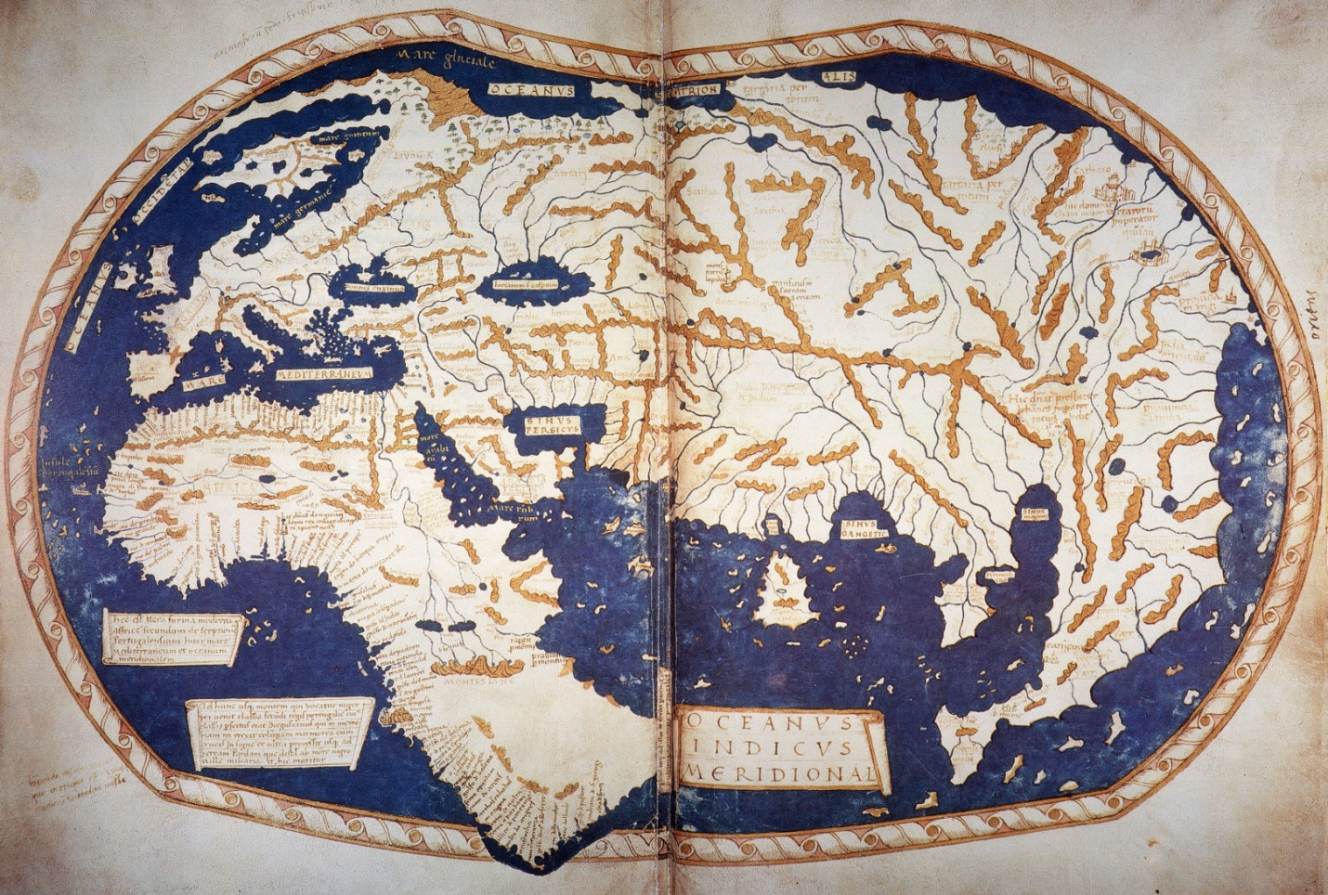
Asia
Europe

6. Above is a map of the world in 1489, 3 years before Columbus set sail on his first voyage in 1492. Explain why Columbus would believe that he could easily sail west and reach Asia. Why would sailing have been easier than traveling across land?

