Multiple Choice/Matching Questions:

- How did the Renaissance contribute to the Age of Exploration?

By awakening a spirit of discovery and innovation in Europeans causing them to want to discover more.

- What new technologies allowed for European’s to start exploring (3 specific technologies)? What did each of these new technologies specifically do?

Caravel Ship – Light fast ship good for exploring, set lower in the water allowing it to withstand larger waves and carry more cargo.
Compass – allowed sailors to know which direction they were going because it always points North.
Astrolabe – measured latitude and could tell sailors what time it was.

- Which European countries took part in Exploration voyages

Spain, Portugal, England, France, and the Netherlands/Dutch

- What two European countries started European Exploration? Why were these two the first to start exploring?

Spain and Portugal, their geographic location on the Iberian Peninsula was advantageous.

- Explain the Columbian Exchange. What were the effects of the Columbian Exchange?

Columbian Exchange is the global exchange of plants, animals, and diseases between Europe, Africa, Asia, and the America’s.
Effects:
- The exchange of foods and animals had a dramatic impact on later societies.
- Introduction of new foods to both Europe and the Americas

- Describe the impact of the Columbian Exchange on the lives of Europeans. BE SPECIFIC/DETAILED.

The combination of new plants, animals, and ideas being traded caused large economic growth for the people and countries of Europe.

- Describe the impact of the Columbian Exchange on the lives of Native Americans. BE SPECIFIC/DETAILED.

The Columbian Exchange killed 90% of the Native Americans due to European diseases in which they had no immunities too.

- What was the Atlantic Slave Trade? What were the causes and effects of the Atlantic Slave trade? BE SPECIFIC.

Refer to your foldable.

“The stench of the hold. . . was so intolerably loathsome, that it was dangerous to remain there for any time. . . The closeness of the place, and the heat of the climate. . . almost suffocated us. . . The shrieks of the women, and the groans of the dying, rendered the whole scene of horror almost inconceivable.”
—Olaudah Equiano, The Interesting Narrative of the Life of Olaudah Equiano, 1789
- Explain what the author is describing in the passage.

The author is describing the conditions on a slave ship on its voyage during the Middle Passage.

“Our plantations. . . consume more of our home manufactures. . . they produce commodities indispensably necessary to this part of the world, and not to be produced elsewhere, and, with industry and conduct, may be made an inexhaustible mine of treasure to their mother kingdom.”
—Charles D’Avenant, “An Essay on the East-India Trade”
- Explain what the author is describing in the passage.

The author is describing the colonization and the importance of colonization on/for the mother country.

- Define capitalism. Describe its effects on the economies of the European countries that took part in exploration.

An economic policy where businesses are privately owned by individuals or organizations. Spurred vast amounts of economic growth for European countries and individuals.

- What was the Treaty of Tordesillas? Which countries did it affect the most? What impact did it have on these countries?

Split the New World between Spain and Portugal. Spain gained most of the land from the Treaty allowing them to have a bigger influence on the America’s.

- What is a Joint Stock Company? Explain its purpose when it comes to the Age of Exploration (what did it do/allow for Europeans to do?)

Business in which several people went in together for a common purpose, it allowed Europeans to make risk – free investments in overseas business ventures allowing them to become very wealthy.

- Which animals were traded as a result of the Columbian Exchange? Be specific as to which animals were native to the Old World (Europe) and the New World (the America’s)?

Refer to the chart in your foldable.

- Which plants were traded as a result of the Columbian Exchange? Be specific as to which plants were native to the Old World (Europe) and the New World (the America’s)?

Refer to the chart in your foldable.

- What was the encomienda system? What caused the shortage of labor for this system?

Enconmienda system was a system where Spanish colonists were given land and natives to work the land in return the colonists would teach the natives about Christianity. European diseases killed Native Americans causing a shortage of labor for the enconmienda system.

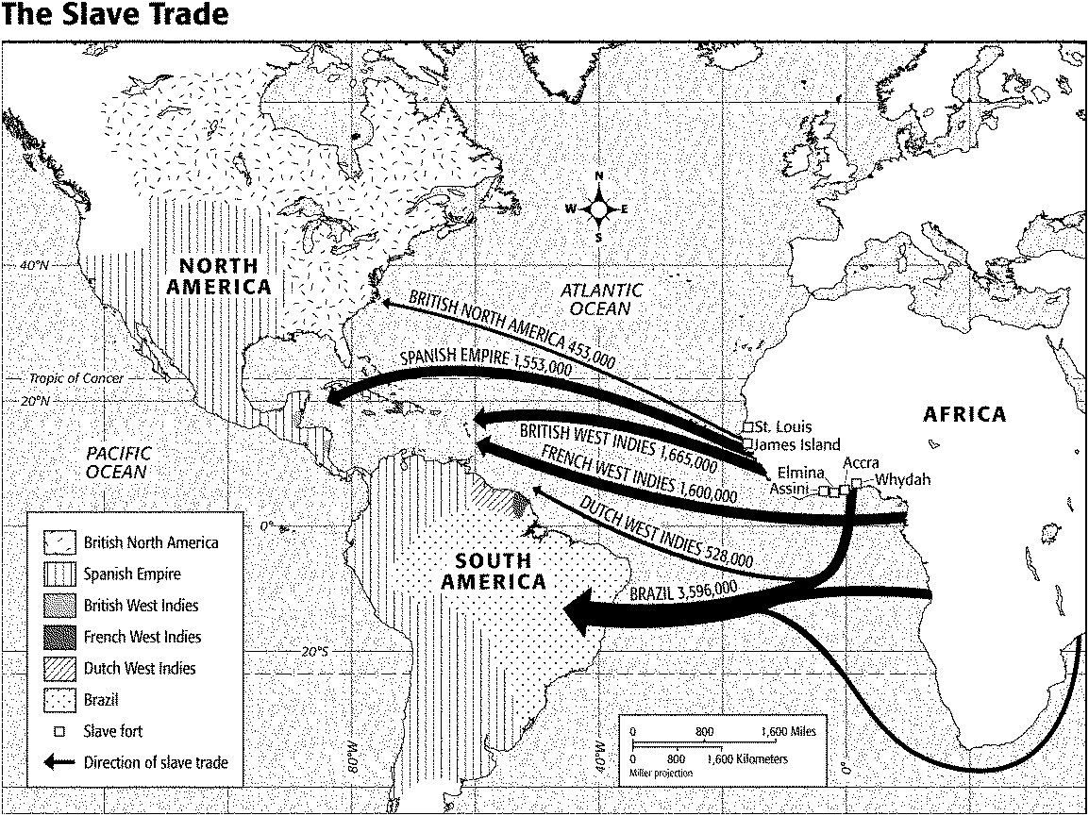
- Where are most of the slave forts located in Africa?

Most of the slave forts were located in West Africa.

- According to the map the majority of African Slaves were taken to which country? How many slaves did this country import?

Majority of African slaves were taken to Brazil. Brazil imported 3,596,000 slaves.

- According to the map how many slaves did the British import into its colonies? How many slaves did the Spanish import into its colonies? How many slaves did the French import into its colonies? How many slaves did the Dutch import into its colonies?

British = 2,118,000 slaves French = 1,600,000 slaves
Spanish = 1,553,000 slaves Dutch = 528,000 slaves

- According to the map which country controlled the most land in North and South America at the time?

Spain controlled the most land in North and South America at the time.
Review Questions”
- What was the Council of Trent? What did it address within the Catholic Church?

The Council of Trent was a meeting of church leaders that addressed corruption, and argued for the role of the Catholic Church in salvation during the Catholic Counter-Reformation.

- Who was Desiderius Erasmus? What did he write about during the Renaissance? What did the Catholic Church do to him in response for his writings?

He was Renaissance writer who mixed humanist and Christian ideals causing him to be condemned by the Catholic Church.

- What was the Edict of Worms? What did it do to Martin Luther?

It made him an outlaw and condemned his writings.

- Define the Medieval Manor System. What was its purpose? What type of system was it social, political, or economic? What caused the end of the Medieval Manor System?

An economic system that was built around large estates that wanted to be self-sufficient. The Black Plague ended the medieval Manor System.

Constructed Response:
- Explain the motivations for European exploration (can be answered in 3 words). Explain each of these reasons. How did the Renaissance contribute to the Age of Exploration?

Gold - Europeans were searching for luxury goods and wealth. God - They wanted to spread Christianity. Glory - They desired fame and glory. They were driven by curiosity.

During the Renaissance, a spirit of discovery and innovation had been awakened in Europe. Inspired by medieval travelers such as Marco Polo, that spirit of curiosity led Europeans to set sail on voyages of discovery in the latter part of the 1400s and 1500s to find new lands or new routes to places already known.

- How did Mercantilism lead to intense competition between nations for wealth during the 15002 and 1600s? How did Mercantilism affect European colonization of parts of the world?

Mercantilists believed that there was a fixed amount of wealth in the world, and that a nation’s strength depended on its wealth. For one nation to become wealthier and more powerful than other nations, it had to take wealth from another nation.

The building of colonial empires was essential to mercantilism. European countries wanted to establish colonies in order to control sources of raw materials and provide new markets for manufactured goods. A nation that controlled its own sources of raw materials would not need to import them from competing nations, and could keep the resources from other countries.

- Compare and contrast the colonies of the countries you listed for question number 3. You may draw a chart, but you must compare and contrast every colony to each other.

Sample Answer: Unlike the Spanish and Portuguese, the French did not send large numbers of colonists to the Americas. Only small groups of traders moved across the sea. The French population remained small. The French were mostly fur traders and fishers. The French did not enslave Native Americans, but traded with them, and sometimes married them.

- Explain Triangular Trade. Describe each leg of Triangular Trade.

It was a network of trade. European ships brought goods to Africa to be exchanged for slaves. They forced Africans into slave ships and brought them to the Americas to be sold as slaves. This leg was known as the Middle Passage. Ships then carried American products such as sugar, tobacco, and rice to Europe. The three legs of this journey were called the triangular trade.

